Recel Jimenez

rjimenez@pceftpos.com.au

Pay at Table Setup Guide

Contents

Overview 2

1. Setup the PC-EFTPOS Software and Pinpad 2

2. Setup the Application 2

2.1 Setup the Test POS (Active X) 2

2.2 Setup the Test POS (IPInterface) 2

2.3 Setup the REST Api Server 3

3. Setup the Pay At Table extension 4

4. Testing 5

# Overview

This document provides instructions on setting up your environment for the Pay At Table system. The following must be setup:

1. Pinpad and EFT-Client
2. Pay at Table extension
3. Test POS

# Setup the PC-EFTPOS Software and Pinpad

The PC-EFTPOS software and pinpad must be setup properly in the desired PC.

1. Install the pinpad to the desired PC.
2. Install the latest PC-EFTPOS software from <https://pceftpos.com/downloads/>.
3. Ensure that the pinpad is working alongside the installed software.
4. Stop the PC-EFTPOS Client service from Services.

# Setup the Application

The Pay At Table extension can be accessed via REST Api server or via the POS (see Pay At Table API documentation for details). The following sections explain how to set up each demo application.

GitHub Download link: <https://github.com/pceftpos/PCEFTPOS.PayAtTable>

# Setup the Test POS (Active X)

1. Download the source from Github.
2. Under PayAtTable.TestPos\PayAtTable.TestPos folder, open and build the “PayAtTable.TestPos” project in Visual Studio 2015.
3. Run the project or the output exe. Verify the connection with the pinpad by clicking the “Pinpad Status” or “Force Send Settings” button. Make sure to complete the steps until section 3 before doing so.

# Setup the Test POS (IPInterface)

1. Download the source from Github.
2. Under PayAtTable.TestPos\PayAtTable.TestPos.IPInterface folder Open and build the “PayAtTable.TestPos.IPInterface” project in Visual Studio 2015.
3. Run the project or the output exe.
4. Click the “Connect” button. Press the “Get Status” button to ensure connection has been established.

# Setup the REST Api Server

The Pay AT Table requests can be accessed via a REST Api external server ( see Pay At Table API documentation for details).

1. Download the source from GitHub.
2. Open and build the project “PayAtTable.Server” in Visual Studio 2015.
3. Open the Project Properties, and under Servers, select “Local IIS”.
4. Set the Project URL to <http://localhost/payattable>.
5. Click the “Create Virtual Directory” button.
6. Set the “Start URL” to <http://localhost/payattable/api/settings>.
7. Run the project using any browser. The browser should open showing the result of the /api/settings request.

Microsoft Edge:

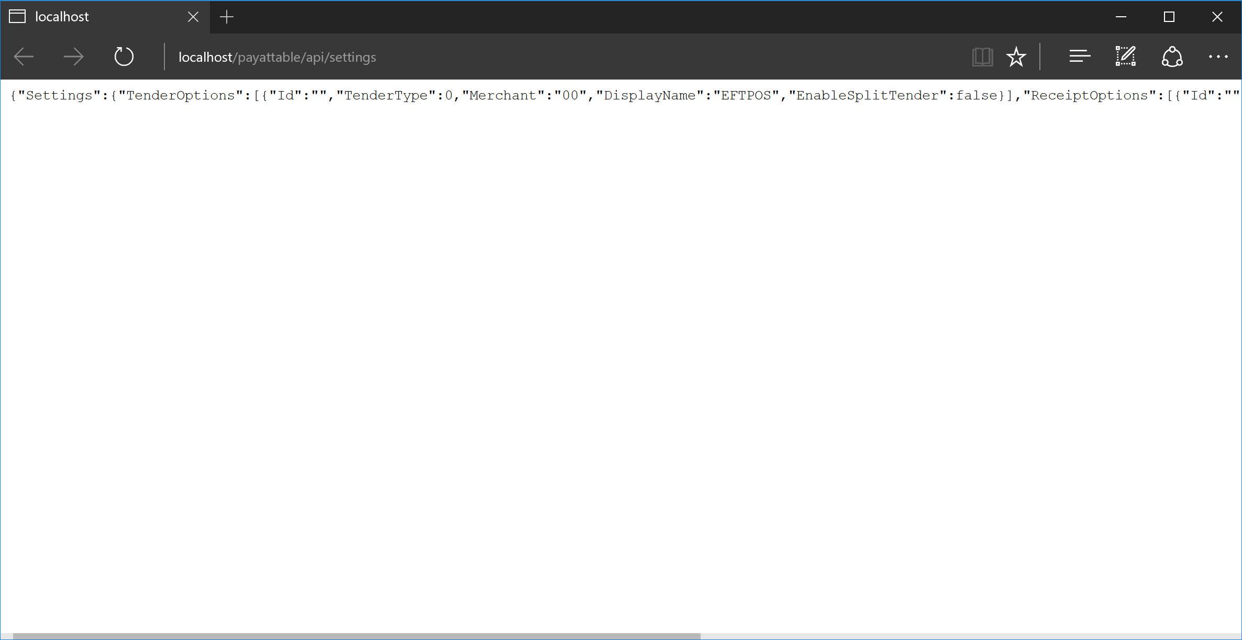

Google Chrome:

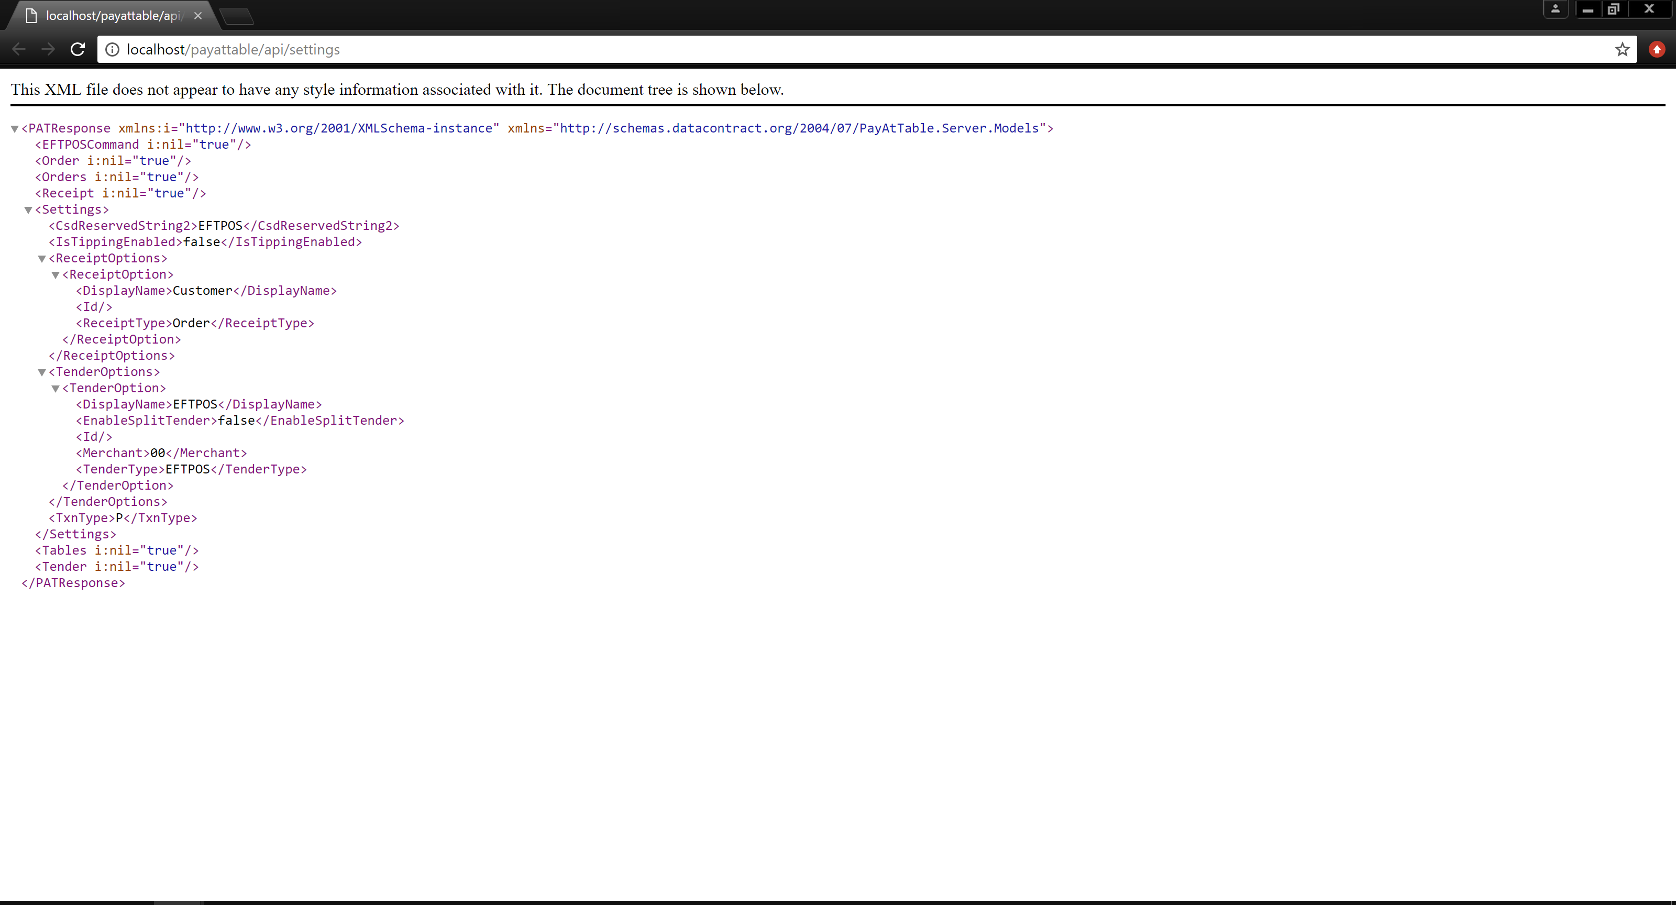

# Setup the Pay At Table extension

1. Download the PayAtTable.Extension folder from GitHub.
2. Copy the contents into the PC-EFTPOS Software installation directory.
3. Setup the registry flags:
   1. Create registry key: HKEY_LOCAL_MACHINE\SOFTWARE\CullenSoftwareDesign\PCEFTPOS_BRIDGE\TPP-PAT
   2. To test using Local POS: Create a DWORD value named "USE_LOCAL_POS**"** with a value of 1.
   3. To test using REST API server:
      1. Create a DWORD value named "USE_LOCAL_POS**"** with a value of 0.
      2. Create a string value named “SERVER_BASE_URI” and set this to the project URL used in the REST Api Server (see section 2.3).
   4. Create a string value named "PAT_FUNC" with a value of 8787 (unique code to identify function request).
   5. Create a DWORD value named “PINPAD_DELAY” and set a value in milliseconds for the pinpad delay. Default is 1000 in decimal.

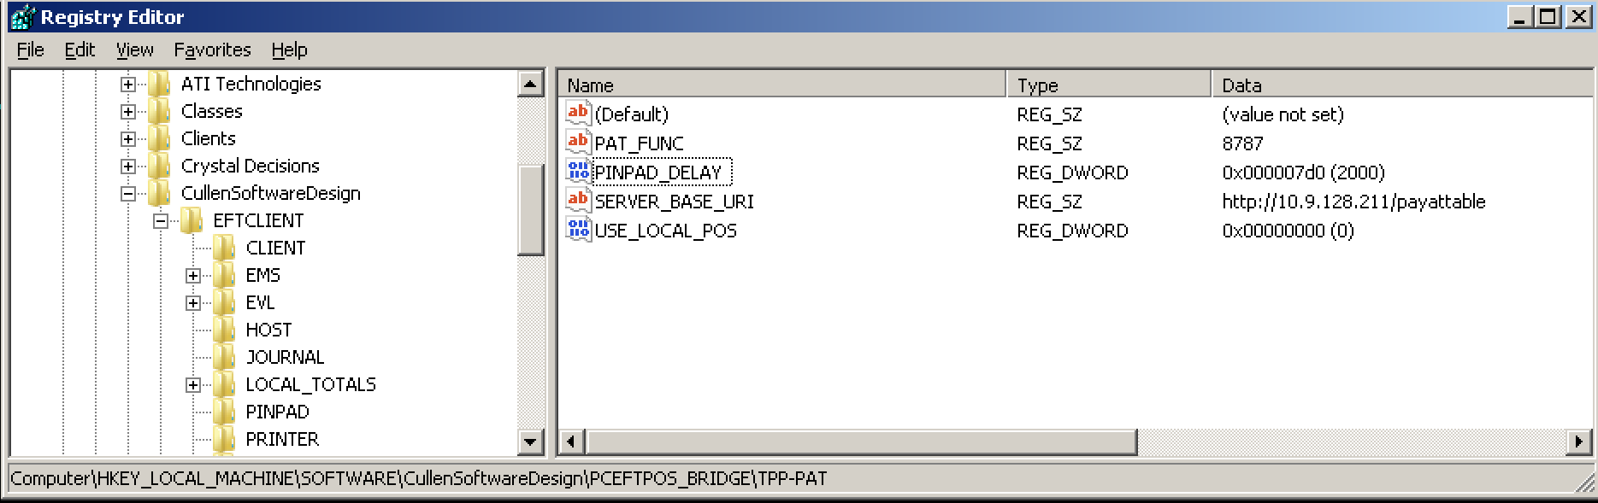

1. Run the PC-EFTPOS Client service (EftClnt.exe). Make sure it is connected to the pinpad by checking that it is ONLINE.

# Testing

To make sure that everything is setup correctly, follow these steps:

1. Run the PC-EFTPOS Client service (EftClnt.exe). Wait for the EFT-Client to be online. The pinpad should display that it is online/offline.
2. Run the Test POS or REST Api project. Make sure it can communicate with the pinpad. See each corresponding section for details.
3. In the pinpad, press the “Func” key.
4. Enter the 4-digit value specified in section 3.10.d (eg. 8787). The pinpad should begin to display the Pay At Table instructions.